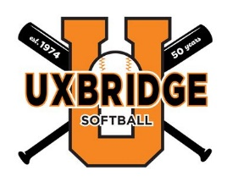
2024 Sponsorship Form
Sponsorship Levels (please select one):
Platinum Level:
- Pricing: $650
- Included with Membership:
  - Team named for your business.
  - Commemorative plaque with team picture
  - Decorative banner with your company name to be carried by players during our opening day parade and then displayed at the Whitin softball fields for the 2024 season.
  - In-Season shout-outs to your business on the Uxbridge Softball Association Facebook page
Gold Level:
- Pricing: $450
- Included with Membership
  - Decorative banner with your company name to be displayed at the Whitin softball fields for the 2024 season.
  - Commemorative plaque
  - In-Season shout-outs to your business on the Uxbridge Softball Association Facebook page
Silver Level:
- Pricing: $250
- Included with Membership
  - Commemorative plaque
  - In-Season shout-outs to your business on the Uxbridge Softball Association Facebook page
Contact Information:
Company Name: _________________________________________________
Contact Person: __________________________________________________
Phone Number: __________________________________________________
Email:__________________________________________________________

*Please make checks payable to the Uxbridge Softball Association. Checks may be mailed with completed form to:
Uxbridge Softball Association
PO Box 441, North Uxbridge, MA 01538
Pick-up of payment and your completed form may also be arranged. Please email uxbridgemasoftball@gmail.com or message the Uxbridge Softball Association Facebook page with any questions or to schedule pick-up.

All donations are tax deductible!
Tax ID: # 04-3117132

Thank you for your support!

